In the Cardiff County Court Case numbers 1CF0336, GA00TA220 & CF057/2021/CA
Maurice John Kirk (Applicant) v South Wales Police & G4S Custodial Services Ltd (Respondent & Defendant)
Skeleton Argument in the light of 2nd December 2021 Bristol G00TA220 civil claim, re- instatement by HHJ Taylor for ‘specific disclosure’ of G4S robbed property, including prisoner’s incoming and outgoing mail, MP letters, his Caswell Clinic, HMP Cardiff and G4S Park prison medical records, his new wheelchair, prisoner witness statements, his 1CF03361 files and other files, his clothes and shoes.
The Appellant is unable to supply the Appeal Court’s requested ‘paginated’ appeal bundle, in full, if whatever his barrister submitted earlier is not sufficient without the disclosure of the Appellant’s G4S stolen ‘machinegun’ legal papers paginated on its Parc Prison Statutory Instrument Rules inventory identifying the content of their victim’s cell on 1st Nov 2019.
Background
Apart from a needed outside police investigation today the Applicant twice noted the following:
With a frustrating background of the above parties’ respective legal advisors and respective law courts failing to disclose to the litigant in person all relevant communications by post, email, text, telephone or otherwise for the Applicant, he files the following ‘Skeleton Argument’ to be attached to his 3rd Dec 2021 N244 form already filed with the Cardiff Appeal Court.
cc | Appeals clerk at Cardiff Justice Centre again states today, to progress the Applicant’s case, the Applicant has to file the 'appeal bundle" which completely contradicts what others say, in that it has already been done.  Last week the court on the phone said I needed to file another N244 form asking for an extension of time to file 'appeal bundle'. But the court has not forwarded the letter of instruction to exclude the litigant in person.  Also, told me a transcript was approved by trial judge on 29th September 21....as litigant in person please also forwarded proof of the following:  Also, last week, court told me written instructions had been received that court correspondence, since 15th September 21 trial, that had ended so abruptly, was not to come to me, the litigant in person, meaning any of the subsequent court or inter party’s communications.  Please forward all docs of this case created from all parties since and including 15th September 2021  This is a repeat of Taffia tactics surrounding the cover-up and blocking of my 2013 BS614159 + 2 (40 odd failed SWP malicious criminal prosecutions appeal) I, three times personally took to the RCJ to file in the Court of Appeal.

- HONOUR JUDGE PETTS WAS ADVISED BY THE POLICE’S QC NOT TO READ MY ‘TRADING IN MACHINE GUNS’ T20097445 CRIMINAL TRIAL ACQUITTAL TRANSCRIPT

- while the learned judge refused my N244 Application for relevant CPR disclosure.

- Followed by the learned judge and Police QC expressing a view that after my acquittal a Newport gun shop 'must' have decommissioned the 'prohibited weapon' before sending prosecution exhibit ARH1 (replica machine gun) to Birmingham Proof House. But the gun shop has confirmed it never had permission to ‘modify’ ARH 1.

- So, the court erred in avoiding the mysterious three-day disappearance of the prosecution item, ARH1, following my 22nd June 2009, arrest as it had gone to Nottingham police HQ first where it was deemed not to be a ‘prohibited weapon’.

- From Nottingham HQ the police took ARH1 to Gold Group (Barbara Wilding) at South Wales Police’s HQ and then onto Chepstow forensic laboratory. At either place it was where the ‘barrel’ of ARH1 film prop was unblocked and painted back from silver to black, the colour when I had owned it years earlier, all to fool my jury.

- That was the guess expressed by eight of the jury in front of my family members at the Haha pub immediately after my acquittal and that decision had been made only after the second day of prosecution witnesses having been cross examined.

- This meant, apart from the obvious police ‘plant’ on the jury, who had refused to discuss the case throughout the near three-week trial, all eleven then sought acquittal.

- Even 10 year old Genevieve Kirk traced the 2000 mile journey, while South Wales Police were frantically hawking ARH1 (contrary to Home Office regulations) around the UK, were trying to find someone to support the Gold Group’s conspiracy.

- 21-09-12-1cf03361-mg-n244-application-notice-1Download

- Failed South Wales Police Disclosure of evidence forced me to pay for a 12th Sept 2021 court application to disclose some of the key evidence proving there had been malicious criminal prosecutions by senior Welsh police officers for over 13 years.

- N244 Application notice

- For help in completing this form please read the notes for guidance form N244Notes. Find out how HM Courts and Tribunals Service uses personal information you give them when you fill in a form: https://www.gov.uk/government/organisations/hm-cou rts-and-tribunals-service/about/personal-information [1] charter

- Name of court County Court at Cardiff Claim no. CF03361 Fee account no. (if applicable) Help with Fees – Ref. no. (if applicable) H W F - - Warrant no. (if applicable) Claimant's name (including ref.) Maurice John Kirk Defendant's name (including ref.) Chief Constable of South Wales Police
Date12th Sept 2021
1. What is your name or, if you are a legal representative, the name of your firm? Maurice John Kirk
2. Are you a Claimant Defendant Legal Representative Other (please specify) Applicant. If you are a legal representative whom do you represent?
3. What order are you asking the court to make and why? An Order for Specific Disclosure of documents as set out under CPR 32.12.and for the issuing of witness summonses.
4 Have you attached a draft of the order you are applying for? ✓ Yes No
5. How do you want to have this application dealt with? ✓ at a hearing without a hearing at a telephone hearing
6. How long do you think the hearing will last? 2 Hours Minutes Is this time estimate agreed by all parties? Yes No
7. Give details of any fixed trial date or period None
8. What level of Judge does your hearing need? District Judge
9. Who should be served with this application? Dolmans solicitors on behalf of the Chief Constable of South Wales Police 9a. Please give the service address, (other than details of the claimant or defendant) of any party named in question 9. 2
10. What information will you be relying on, in support of your application? the attached witness statement the statement of case ✓ the evidence set out in the box below
The Defendant to disclose:
1. Gold, Silver, Bronze, MAPPA, OASys, MG6D and PII records of Operation Orchid
2. All records re police helicopter flights re Operations Chalice and Orchid
3. All Vale of Glamorgan and Cardiff records of Operation ‘Orchid’ & ‘Chalice’
4. Gold, Silver, Bronze, MAPPA, OASys, MG6D and PII records of Operation Chalice
5. Gold, Silver, Bronze, MAPPA, OASys, MG6D and PII records of Operation Bridger
6. All minutes relating to Gold Groups are retained locally by that 'OCU'. (These documents must include closure reports, Gold Group logs and other material such as Critical Incident Management Logs).
7. Nottingham police records relating to Operation Chalice and exhibit ARH1
8. Scott Arms records relating to Operation Chalice and exhibit ARH1
9. Duxford Museum records relating to ARH1
10. Bedford Shuttleworth Air Museum records relating to Operation Chalice (five machineguns)
11. Chepstow Forensic Scientific Services records relating to Operation Chalice and ARH1
12. RAF records (2000 Farnborough Airshow and Lynham airfields) of exhibit ARH1
13. Gold, Silver, Bronze, MAPPA, OASys, MG6D and PII records of ‘Foxy’
14. Gold, Silver, Bronze, MAPPA, OASys, MG6D and PII records of PC Nigel Brown
15. Full content of all police and retired police personal pocket notebooks of Operation Chalice
16. Full content of HMP Cardiff & G4S run HMP Parc records of Operation Chalice & Orchid
17. Full content of HMP Parc stolen Caswell Clinic medical records of Claimant re Operation Chalice and civil claim 1CF03361
18. Andrew Huxtable Prosecution exhibits AH1 &AH2
19. Andrew Huxtable’s Home Office controlled video and photographs of his examination of ex ARH 1
20. Litts of Newport gun shop, South Wales, records relating to Operation Chalice and ARH1
21. Medica records of Bridget Craddock re Operation Chalice and Orchid
22. Medical records of Dr Metters re Operations Chalice & Orchid.

The Cardiff Court to issue witness summonses, to the following, to attend 1CF93361 civil damages claim on behalf of the Claimant:
i) Tim Dodson, clerk of court, with Claimant’s defence statement for T20097445 & court log
ii) Kirstie Kirk with records of her Operations Chalice and Orchid involvement
iii) Genevieve Kirk with records of her Operations Chalice and Orchid involvement
iv) ‘Foxy’, under cover police officer, with his records of Operations Chalice and Orchid
v) Nigel Brown of South Wales Police with his records of operation Chalice and Orchid
vi) Retired DC James Philips with his records of Operations Chalice and Orchid
vii) Retired inspector Phil Davies with his records of Operations Chalice and Orchid
viii) Police officer Kerslake with his records of Operations Chalice, Orchid & BS612159 damages claim
ix) Police officer Redrupp with his records of Operations Chalice and Orchid & BS612159 damages claim
x) Police officer Williams with his records of Operations Chalice Orchid & BS612159 damages claim
xi) Police officer Andrew Rice with records of Operations Chalic Orchid & BS612159 damages claim
xii) Police Officer Davidson with his records of Operations Chalice/Orchid & BS612159 damages claim
xiii) Police Officer Morgan with his records of Operations Chalice/Orchid & BS612159 damages claim
xiv) Police Officer Dyson with his records of Operations Chalice/Orchid & BS612159 damages claim
xv) Appropriate Adult Mr Reeves who witnessed Operation Chalice & Orchid helicopter raid
xvi) Retired Chief Superintendent Stuart McKenzie OIC of Operations Chalice and Orchid
This list is far from exhaustive
3 Statement of Truth
I understand that proceedings for contempt of court may be brought against anyone who makes, or causes to be made, a false statement in a document verified by a statement of truth without an honest belief in its truth. ✓ I believe that the facts stated in section 10 (and any continuation sheets) are true.
The Applicant believes that the facts stated in section 10 (and any continuation sheets) are true. I am authorised by the applicant to sign this statement. Signature ✓ Applicant Litigation friend (where applicant is a child or a Protected Party) Applicant's legal representative (as defined by CPR 2.3(1)
On the 18th May 2019, on instructions from the Gold Group under the Chief Constable, the 2nd Defendant, the Governor of the Cardiff prison, allowed the theft of not just my G4S legal papers from my prison cell but blocked my mail both in and out of the prison for months.
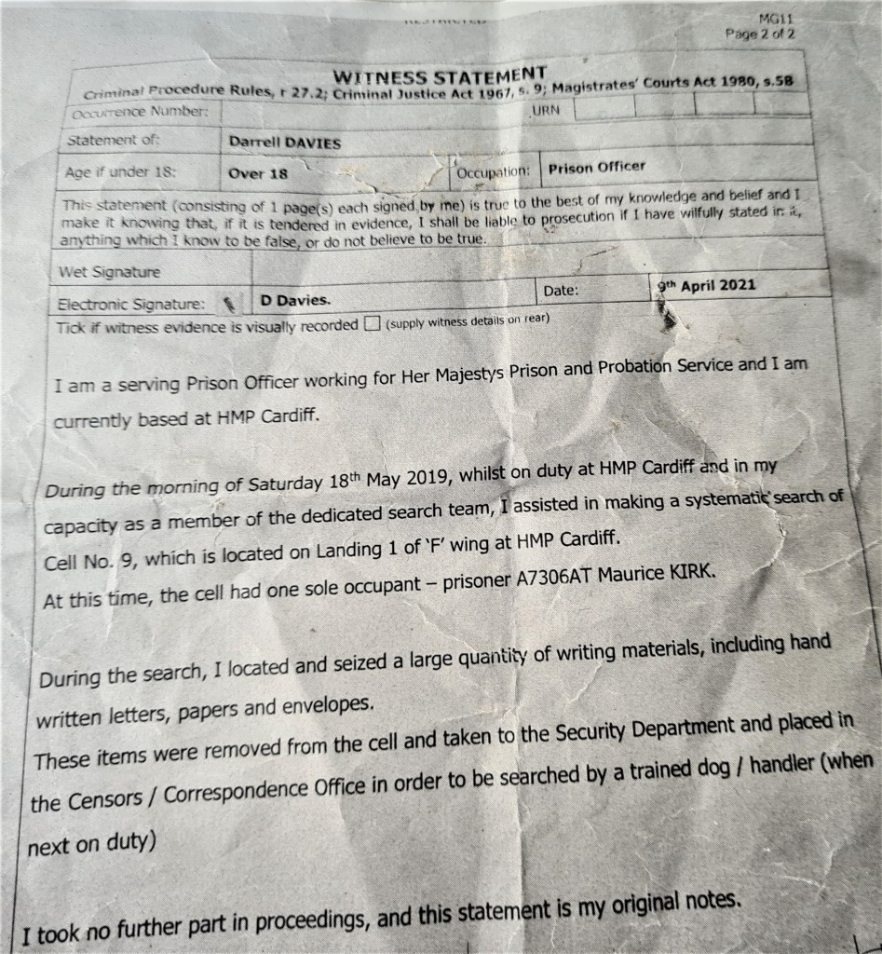
South Wales Police falsified OASys records and circulated them world-wide so G4S data contained false criminal convictions for firearms, child abuse and narcotics.
G4S staff leaked these highly unlikely convictions to both Cardiff and Parc prisons and my parole officer, signing off each one, who finally had them expunged from the record to immediately secure my release from prison following my favourable October 2019 Parole Board hearing witnessed by retired Celia Jeune, my retired magistrate sister.
Evidence of falsified criminal prosecutions:
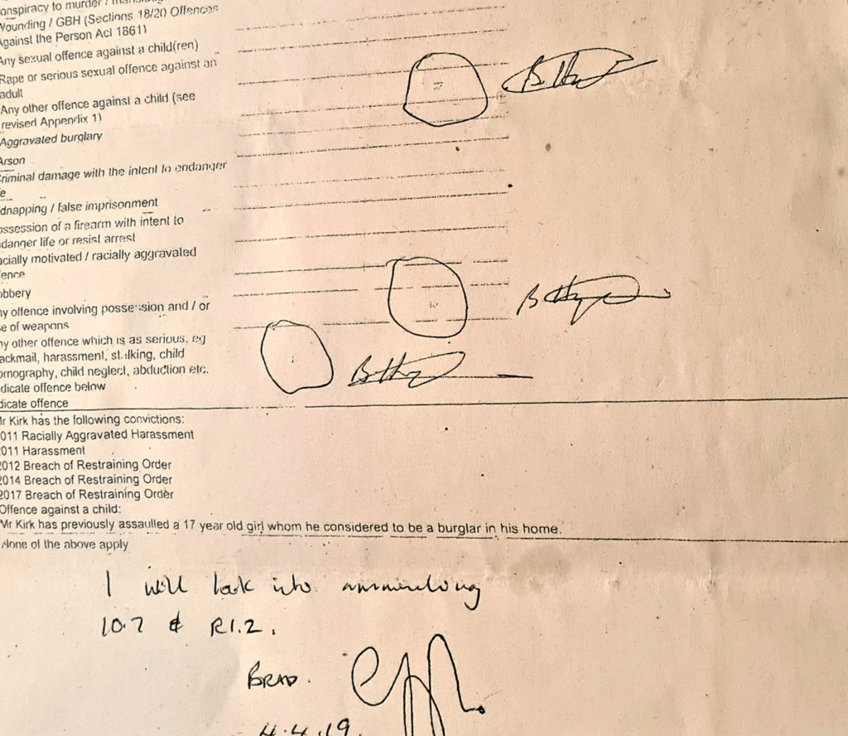

30 odd Prison stopped letters by both prisons
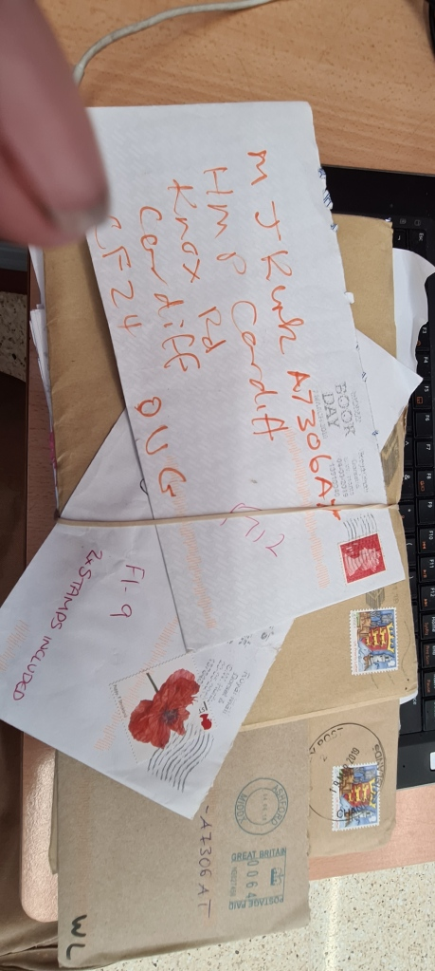
30 odd Prison stopped letters by both prisons 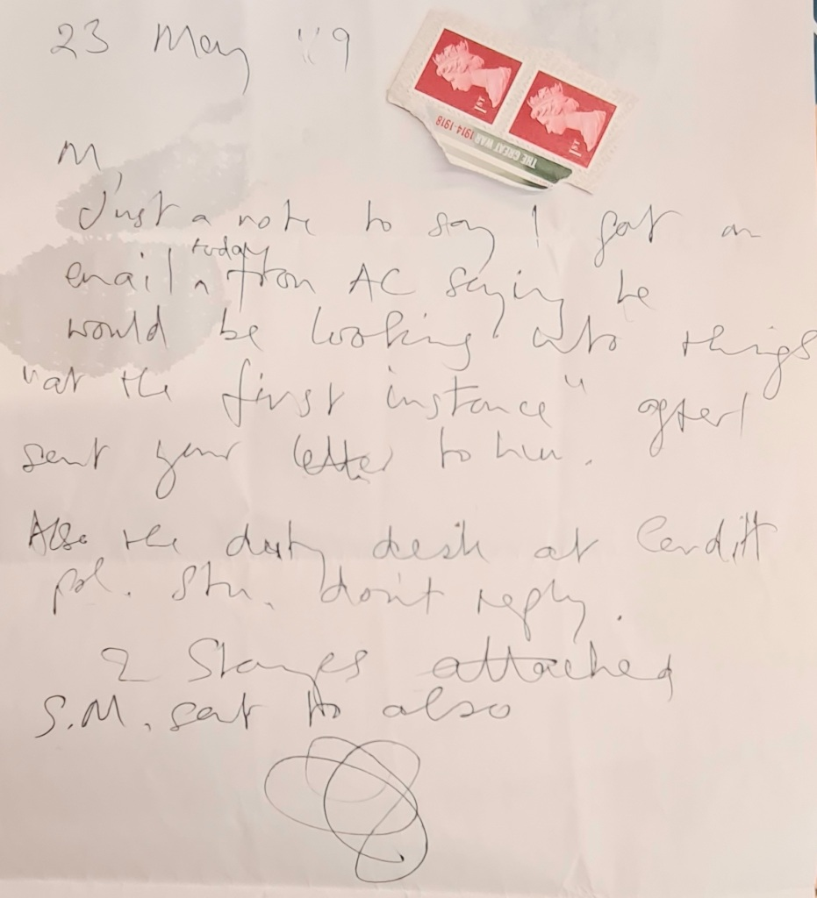
This application has arisen because from 10 May 2021 to 20th May 2021 I was taken ill and admitted to hospital at a thoroughly insulting jury trial at Exeter Crown Court after which I was acquitted. Although attending my home address and accessing my emails I never saw any communication from Bristol County Court of a 15 May 2021 listing in case GA00TA220 or I could simply have said to Bristol court that I was at Exeter Crown Court on that day.
I also paid a court fee of £10,000 which I believe demonstrates how seriously I regarded and committed I was to the G4S matter in Bristol linking it to BS614159 appeal (40 odd South Wales Police failed malicious criminal prosecutions) and the equally alarming 1CF03361 'trading in prohibited weapons' civil claim also arising from South Wales Police malfeasance.
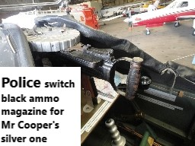
I ask the Court also to take into account that in 2021 at 76 years I have what some may describe as an age-related cardiovascular deterioration (GP letter enclosed) where I have been in NHS hospitals inpatient ward three times in May and June 2021 and was given an assortment of medication for severe AF (atrial fibrillation). It is well known that an elderly person starting such medication will have very considerable problems with struggling to be able to think and organise themselves due to the oxygen starvation to the brain.
My ‘significant brain damage’ condition was first recorded in the Caswell Clinic, South Wales medical report dated 19th Oct 2009 by Dr TW, now sacked for rampant dishonesty, advising the 2nd December 2009 Cardiff Crown Court, in my forced absence and without legal representation my real medical need for 'legal representation' in the imminent 'machinegun' trial.
All in court knew, full well, I was bound to win the disgraceful allegations as the RAF and civilian gunsmiths had already deemed prosecution exhibit ARH1 not 'decommissioned' as the film prop had been put together for the film 'Gunbus' as a single shot 0.410 shot gun to fire star shells at air shows.
Had paperwork for the 2000 Farnborough Air Show not been so daunting in the precious time remaining then Captain Brian Trubshaw, of 002 fame, would of had 'his money's worth when inviting me to display my replica 1916 Battle of the Somme DH2 biplane as I had other pyrotechnics as well in my 'arsenal'.
https://images.app.goo.gl/cnAvXoHg1Q7e8FMJ7
The ARH1 prosecution exhibit was in a shade of black when I bought it and then partially painted silver ( ammunition magazine only) on the day by the new owner, Mr Cooper. Mysteriously to some but not the Claimant nor eight of the jury, commenting in the Cardiff pub on 10th February 2010, in court the magazine was clearly painted back.to black.
When Mr Cooper received back ARH1,, in June 2010 he told us the South Wales Police had not even bothered match up the last painting of the magazine to his shade of’ ‘silver’. Maybe that is why, during the farcical criminal trial at Cardiff Crown Court, I was never allowed to examine the court exhibit when everyone else could. I had, of course, carefully sharpened up my finger nails to deliberately scratch of the new layers of paint put on since my selling her.
So, by June 2010 when the exhibit was into another shade of 'silver' on the magazine, it was returned to Gerry Cooper. The police had returned the 'gun' with yet another shade of 'silver paint' with the mysterious three days between the Nottinghamshire police handing over the exhibit to the South Wales Police yet to be explained. Neither at the criminal trial nor in the very unfair civil trial, my being denied the obviously needed witnesses and exhibits hidden all along by Gold Group in charge, has there been an independent English police investigation.
It was surely comical to witness each of the original criminal prosecution witnesses in the now civil trial exercising their art, learnt from their police college training. for 'selective amnesia' when appropriate.
The June 2009 armed police helicopter raid on our home, requiring over twenty officers on the ground in St Donats in the Vale of Glamorgan, was Gold Group's Operation Challis and Orchid under the control of Barbara Wilding due to her deliberately written February 2009 false sworn affidavit stating proper CPR disclosure had been conducted in both the BS614159 and T20097445 cases and in my many other court cases against her.
My contacts in the police force informed me, after acquittal, that the main purpose of the police raid was to have me 'lawfully shot' as that month's Gold and Silver Groups had been recorded by Elizabeth Paul and is one of my denied prosecution exhibits in 1CF03361 case.
It is most important for the general public to know, as to what really goes on in our UK's judicial system that 'Operation Challis' was combined with 'Operation Orchid' to snatch our then 10 year old daughter, Genevieve, from that afternoon tea party, should I not be shot
I was purported by the 15th June 2009 MAPPA committee, also under Wilding, to be a 'very serious ‘risk' to the general public and even to my own family members!
The subject of 'risk ' or 'real risk' is not an expression completely unknown to the Kirk family with my oldest daughter's grandfathers, one each side of the English Channel on D-Day, Dad operating as a sabotage expert from an underground OB (Operational Base), in the event of German occupation, under either the Somerset Blackdown hills or Quantock hills with the other grandfather as a commander in the French Resistance responsible for some of the D-Day preparation.
Belinda's book, 'Adventure Revolution', destined to be a compulsory school text book, admirably throws some light on the true meaning of 'risk' and especially as her grandmother cried upon hearing that I had bought a veterinary practice in South Wales, of all places!
I brought the G4S case believing that there is a clear principle that it is essential for courts to respect prisoner’s rights because of the high level of control that a prison has over its prisoner (responsible for prisoners’ letters to their respective MPs, for example) - See my T20200177 alleged ‘stalking’ my own Conservative MP acquittal and equally ridiculous T20210178 Exeter Crown Court ‘bladed instrument found in my vehicle’ acquittal.
Regards my compliance with Case Management my understanding is that whereas I can be asked to do obvious easily achievable points of civil procedure it is unfair and potentially unlawful to request a lay person representing themselves to display the skill of a lawyer.
I also refer to Lord Chief Justice Thomas who, before the Justice Select Committee said the Judiciary are concerned that efforts claiming to make the county courts more efficient, were making the courts more unfair.
The 1CF03361 'gun' case is now on appeal as it was clear that both HMP Cardiff and HMP Parc had been given orders by Gold Group to purloin my legal papers whenever possible including my correspondence either in or out of the prisons.
The general public needs to understand no Gold, Silver or Bronze Group’s identifiable paperwork has ever been disclosed to their targeted victim in any of the police's seventy odd malicious criminal prosecutions since its inception or since my buying the Vale of Glamorgan veterinary practice in 1993.
I do not believe a lay person should be asked to cost out their claim as though having the skill of a lawyer but rather a lay claimant should only be asked to do as has occurred in UK Courts for centuries that a lay person has a right to bring an injustice, of such magnitude, before the court.
It is noted, following the two-million-pound police legal bill muted by their QC in the October 2021 1CF03361 very unfair trial, all the culprits are 'hell bent' on stopping any forthcoming appeals or Welsh related costings analysis ever to get before an English court of law because fraud has been proved.
This claim arises from while I served an unlawful incarceration as I should have been released in March 2019 at G4S's HMP Parc, Bridgend, South Wales so the Welsh police had concocted another now proven pack of lies as the Exeter jury fully understood. Witnessed and signed prisoner statements, seeing my prison mail stolen on most days need disclosure in this case and I am relying on the Honourable English Court to assist, thank you.
South Wales Police, the court heard from the CPS, had telephoned my MP in May 2019 informing her that because I had sent a letter (seeking help over my being harassed by the Welsh police with property stolen) I would remain in prison until December 2019 despite my release date being March 2019. The MP fortunately for me wrote the above facts in her MG11 witness statement.
On 1st Nov 2019 I was G4S violently assaulted by G4S staff who confiscated the full content of my cell refusing, they thought amusing at the time, in supplying me with the statutory inventory receipt of property stolen, as laid down by government regulations.
These legal papers included, of course, the imminent ten-year delayed 1CF03361civil claim evidence arising from South Wales Police’s T20097445 ‘trading in machineguns’ failed malicious criminal prosecution concocted by the then 2008 Chief Constable, Barbara Wilding while acting as Gold Group chairperson for the committee. Dr TW, of course, also sat on MAPPA level 3 category 3 monthly meetings to discuss my threat to their respective pensions.
As an aside it is of significant public interest to note that this year, thirteen years after the SWP 'machinegun' conspiracy was hatched, to stop my BS614159 plus other civil claims, His Honour Judge Petts stated I had been 'dishonest' when giving evidence on oath in the October 1CF03361 'gun' trial. No one will elucidate.
Interesting also is that the learned judge and police QC both commented that the Newport gun shop, after my 2010 acquittal, MUST of done 'WORK' on prosecution exhibit, ARH1, to explain away the reason why Birmingham Proof House' certificate clearly records it was never ever a prohibited weapon but, at most, a single shot 0.410 shot gun!!!!
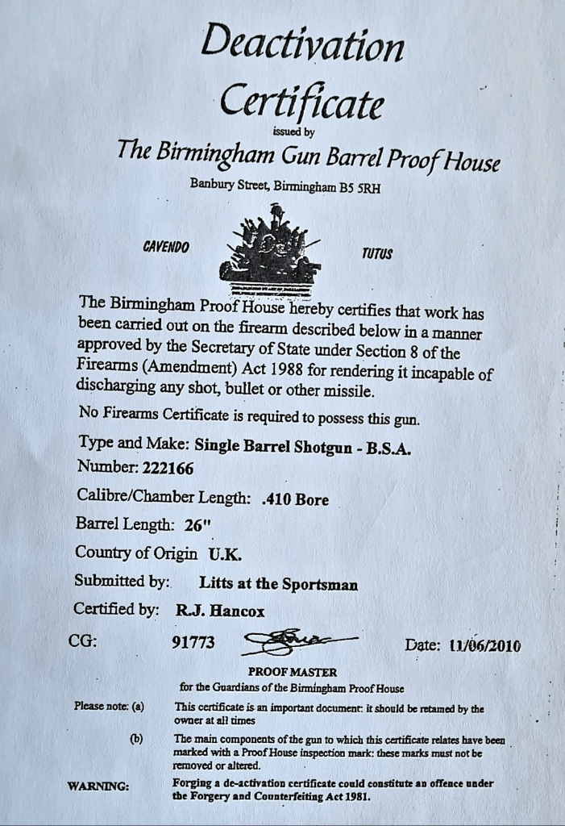
The Newport gun shop staff all went 'berserk' when I was bombarded with their denials only to then quietly produce the certificate stating it was not even a 'firearm'.
Far more important was a copy of their unpaid bill again submitted to the South Wales Police confirming no work had been done by Litts on the ARH1.
A simple call by a lawyer to the Newport gun shop confirmed, of course, no 'work' was allowed to be done by them on an alleged 'prohibited weapon' under s5 of 1968 Firearms Act.
My three years of my Welsh GP medical records, my Caswell Clinic Bridgend records, specifically sent to me for my Taunton GP by Dr Gaynor Jones in November 2018 and clothes, books and two wheelchairs remain stolen by G4S.
They refused to hand them back even ignoring my Devon MP’s letter on the matter. As a consequence, I was prevented from case managing the machinegun claim and accordingly penalised for it at the October 2021 trial.
However, when I say confiscated my legal papers and possessions it was all more brutal than that. On 1 November 2019 my cell was raided by eight prison officers who, without explanation, filmed on body cams, rammed both my arms behind my back and forced on over tight handcuffs. Despite prior knowledge they had no regard for my previously broken wrist, thumb, elbow and shoulder.
South Wales Police’s PNC remarkable disclosure, following my May 2021 MP alleged ‘stalking’ allegations acquittal revealed that during my G4S incarceration in 2018/19 there were, on record, my having previous false convictions including ‘firearms’, ‘child abuse’ and ‘narcotics’ (cultivating, supplying and using).
Whereas the probation officer had success in having these convictions removed for my successful October 2019 Parole Board hearing, ordering my immediate release, there will be similar false data still remaining on my MAPPA 3/3, MG6C, PII and OASys etc police-controlled fairy tale records.
Five FALSE WARNINGS on the South /Wales Police’s PNC, including I was ‘likely to be violent upon arrest’, was revealed for the first time following my T20200177 MP/ police CPR disclosure under Article 6 etc.
I was then violently carried from the prison and without my feet touching the ground placed inside a vehicle and driven out of Wales without my legal papers and possessions. Two bundles of my mail almost thrown at me identified as urgent mail sent to Cardiff prison in early 2019 with the remainder addressed to me, in June onwards, in HMP Parc!
Prior to 1st November 2019 while in custody under the control of G4S I was abused and denied adequate and appropriate medical care.
The abuse included assaults on my person, some recorded in my snatched Comp1/2 prison complaint forms, my being denied my daily Omeprazole, for weeks on end, required for a diagnosed carcinogenic lesion, Barrett’s Oesophagus, following a flying accident for James Bond film, ‘Moonraker’, splitting my diaphragm and significantly damaging my phrenic nerve.
Therefore, the tort includes:
G4S staff, prisoner assaults and thefts in the Parc prison
A lawyer opening my boxes some released G4S stolen property years later, still stealing two wheelchairs, legal files, medicines, clothes, my shoes and official inventory of my cell clearance, of course
https://youtube.com/watch?v=jh53x44upIo&feature=share
G4S induced assaults by prisoners on their misconceived belief of my having been convicted as paedophile, drug dealer and for having a conviction relating to 1968 section 5 prohibited weapons.
G4S withheld my medicines for weeks
and denied the return of my Caswell Clinic medical records sent into the prison for me in November 2018 by Dr Gaynor Jones specifically for my GP
HMP Cardiff also stole both my incoming and outgoing mail for HM Criminal Court of Appeal, Cardiff’s civil court, my GP and family.
Both Welsh prisons deliberately confiscated my applications for Parole, medical help, RCJ appeals, G4S judicial review applications and the recent machine gun case 1CF03361 papers being heard now on appeal in some Cardiff court as I am denied, of course, access to The Royal Courts of Justice.
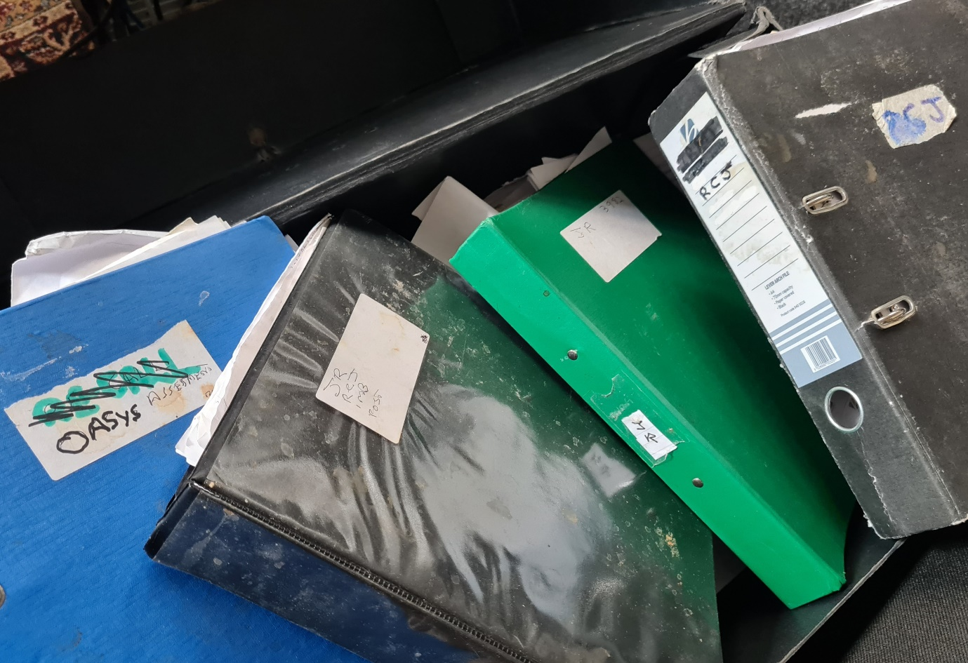
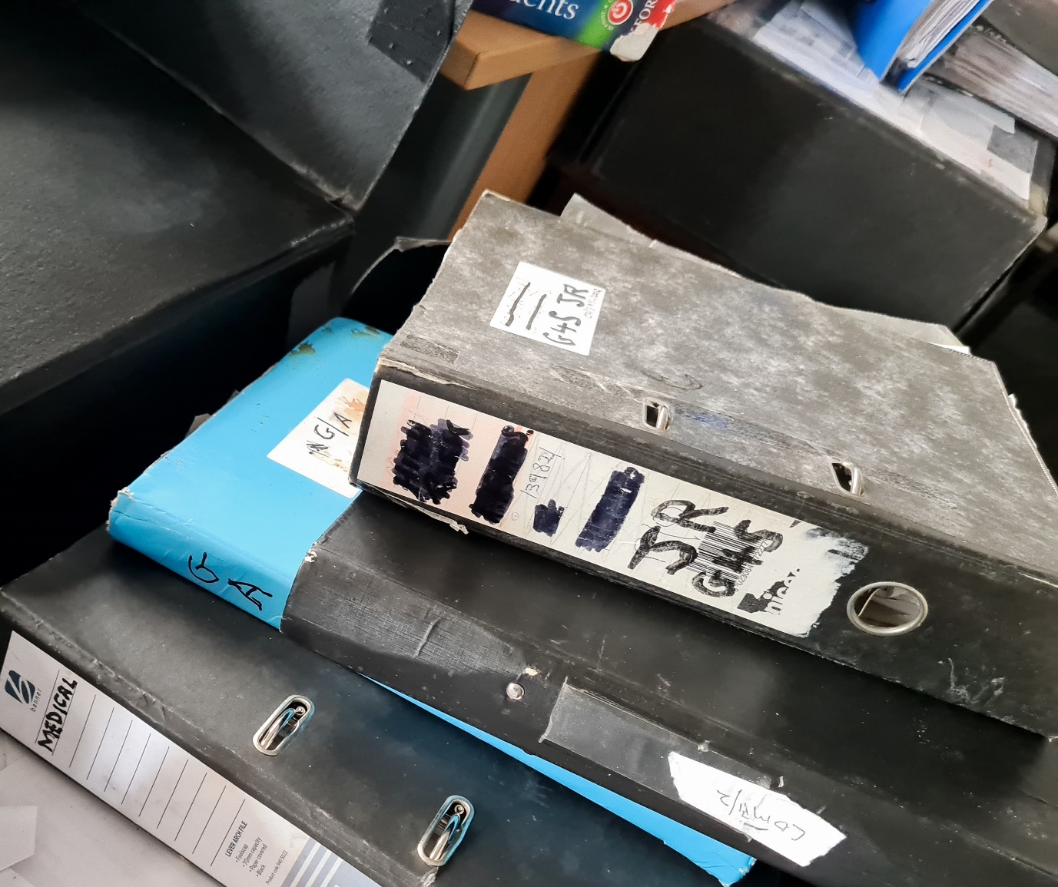
Some of my stolen legal files were only returned to me by G4S in August 2021
Temporary photographic evidence of some of the retrieved Claimant files from G4S recently from four boxes from HMP Parc opened and checked by lawyer.
G4S have stolen my MP/lawyer file including copies of letters to HM Secretary of State for Wales and MP I cannot name by court order, Holborn Adam solicitors, Law Society, Chris Daw QC and Bar Council. My clothes, shoes and two wheelchairs remain stolen.
This list of loss is not exhaustive
- In addition to that critical principle to respect prisoners’ rights, this case is about conduct that is far more malicious than odd breaches of human rights and the background of why I was in HMP Parc is essential to grasp as a means to understand what motivates G4S and what is really going on.
Multi Agency working - colluding with errant police as a perception as to why G4S also acted in bad faith failing to disclose a Chief Constable was also in charge of Gold Group, the officer in charge of T20097445 unknown to the Claimant, 2017 jury or Royal College of Veterinary Surgeons over past 12 years.
- As in the 1CF03361 South Wales Police ‘machinegun’ conspiracy, to secure a 10-year mandatory prison term to block my imminent BS614159 civil claim, both G4S and HMP Cardiff conspired to pervert the course of justice.
- The background is important because it explains the motivation of G4S to try to do the same as SW police to obstruct if not swamp me with obstacles to make it difficult for me to manage my civil legal cases ALL against them.
- This claim arises in a context where I am in a long-term dispute with SW Police and their partners through multi agency working where I alleged that everytime I tried to bring a case before the civil courts to prove my point, mischief occurs by SW Police and their partners (such as Dr T W and G4S), try to undermine my case at the civil courts. (Dr TW was the author of my notorious 19th Oct 2009 psychiatric report recommending I be further sectioned under the1983 Mental Health Act as an IPP prisoner in Ashworth’s high security psychiatric hospital - meaning for life.
- By mid-2009 my case over years of harassment and deceit by SW Police was due to be heard at the civil court. The case concerned nearly two decades of being harassed by police trying to prosecute me and the sheer number of times they tried to prosecute me made for an unassailable inference of mala fides. I was acquitted or a case dropped over forty (40) times. More than 40 prosecution cases were started and I won 89% at one point consisting of more than 123 criminal allegations. A trend which means that it is certain that the reasonable thinking man will suspect that some kind of mischief must be occurring (HHJ comment in 2000 BS614159 Bristol County Court hearing was an example of that).
- Regards this 2009/2010 remand and prosecution over a WW1 film prop dummy Lewis gun the jury believed me and I was promptly acquitted.
- But in August to December 2009 when SW Police felt their prosecution would fail they used their Gold Group multi agency partner Dr TW to deploy reports he must have known were false to try to damage my credibility and get me sectioned to Ashworth indefinitely.
- Importantly Dr TW used a series of one month applications for sectioning to Dr TW’s clinic at the ABM NHS in Bridgend starting 3 August 2009 to assess whether I may have brain damage from aeroplane crashes. This was to assess whether I had brain damage affecting my behaviour which of course included the ability to manage my life.
- His colleague, Professor Rodger Wood, in on the act went further and said in writing my brain damage had been primarily due to my having been a ‘long term drinking partner, Actor, Oliver Reed!
- However, by 29 August 2009 two experts from the ABM NHS Bridgend Radiology Department decided I had a normal brain scan for a man of my age. Therefore, just like my claim against G4S, Dr TW sought to collude with SW Police by not only hiding my NHS formal all clear result from the Cardiff Crown Court but also Dr TW made the leap to an area of medicine in which he is not qualified, to assert as an expert that I had significant irreversible brain damage which impacted on my behaviour.
- Additionally, Dr TW changed his early diagnosis to the Cardiff Crown Court of
“.......consistent with, but not diagnostic of a paranoid illness...”
Dr TW writing to Cardiff Crown Court early September 2009
- In contrast between October and December 2009 Dr TW was trying to Section me indefinitely to Ashworth now claiming I suffered from Paranoid Delusional Order but was unable to explain any unreasonable or unusual behaviour to justify him saying that, other than I was suing SW Police.
- Also, the extreme number of attempted but failed prosecutions or like incidents, meant a reasonable person would think there was good reason to challenge SW Police. Parliament has decided that legal action against the Chief Constable is the correct way to raise issue.
- Dr TW was seemingly colluding with SW Police by attempting to Section me indefinitely on 2 Dec 2009 at Cardiff Crown Court before a jury trial could occur in January/February 2010. But he failed because no other doctors would support him.
- SW Police now promote only the false report of Dr TW as if true while omitting from police records what all the other doctors say. Dr TW says in his report to the Cardiff Crown Court:-
“…My current preliminary position is that whilst Maurice Kirk is fit to plead, his difficulty in organising ……as a result of brain injury……..he would be unable to conduct his own defence
Dr TW point 11 dated 30 September 2009
- After my being acquitted by the jury in 2010 failed prosecutions that take up my time and resources did not stop.
- One of eight of the jury in a nearby public house physically dragged me into a public house near the Cardiff crown court in order to tell me that after the first day of evidence in a two-week trial it was clear I had been ‘stitched up’
- As from 2010 while I tried to avoid SW Police and live in France, SW Police sent my local French police a copy of medical reports by Dr TW that police knew were untrue. I was locked up in a French lunny bin until recognised by a nurse remembering I had had a total hip replacement in there due to Guernsey police having left me handcuffed for many hours with a dislocated hip.
- Additionally in 2010 SW Police tried to prosecute me over trivia of whether trying to attend the civil court amounted to common assault and after a year of disruption to my life that was eventually thrown out of the Magistrates court.
- during the time period of of the BS614159 police incidents seven times I had HORT1producer documents served on me by South Wales Police and seven times I flatly refused to produce, anymore, my driving licence, insurance and MOT documents that led to no cautions or prosecutions.
- Furthermore, as from 2011 SW Police started a series of many prosecutions claiming that my trying to complain with accurate truthful references about them using false reports by Dr TW, amounted to harassment of Dr TW.
- I did manage a year free of SW Police where in 2016 I flew my aeroplane half way across Africa as reported with interest and excitement by the main UK news media and the main media across the world.
- But I could not complete the second stage of my 2016 Africa trip because SW Police arrested me led for two years for saying the truth in a police station about Dr TW.
- My Cardiff Bay police station video account of the Dr T W/South Wales police conspiracy was never investigated.
- SW Police do not like me saying the truth so I was given a two year-sentence for publishing the truth and that is why I was at HMP Parc under the control of G4S.
Are my claims about saying the truth credible?
- Dr TW must have known he was doing wrong because in 2007/8 he wrote Chapter 19 “The expert witness: professional practice and pitfalls” in the Handbook of Forensic Mental Health (Pub: William 2008) explaining not to go beyond one’s expertise and to use other experts if issues are outside of one’s expertise. Therefore, when Dr TW is not medically qualified as a neurologist
- Dr TW not only acted improperly but potentially even criminally in knowingly and so seemingly intentionally misleading the Crown Court, CPS and Police on important issues.
- We can see potential dishonesty regards Dr TW and police use of Paranoid Delusional Disorder (PDD) because they use PDD when they feel it could cause harm, but hide it from the four prosecutions when it would have reduced my sentence by half or even no sentence at all.
- We can use the example of the case of farmer Tony Martin who shot two young intruders as they fled his home. In the Tony Martin case PDD was an integral a part of the case and was the reason why he only received a reduced sentence of three years. Whereas Police and Dr TW arranged I served 5 years in prison for saying the truth on posters and on the interne
- The Police cannot avoid the fact that even though I was acquitted in the 2009/10 Lewis gun case a film prop dummy Lewis gun was not a firearm. Yet the police still have to this day placed on the Police National Computer (and so for the attention of police across the world) that I am a 2009 firearms risk and that I am violent.
Honest Opinions of experienced G4S staff differ to that of police.
- The staff at G4S did not find me as a violent or dangerous risk as SW Police maliciously say or having the severe medical conditions as Dr TW say and SW Police amplify. It may well be one reason why G4S needed to hide my legal and other papers as G4S inadvertently prove the wrong SW Police do in persecuting me by a false assertion of risk that they know is not true.
Claimant won the Cardiff Crown Court jury trial in 2010 and the Exeter Crown Court jury trial in 2021 that both arose from a false assertion of ‘risk’ by the Welsh police.
- As from the 2009/10 prosecution, that SW Police lost, they still placed the Claimant on the Critical Public Protection Risk as one of the very most dangerous people in the UK where by Critical Public Protection Risk those procedures require police local to the prison to inform the constituency Member of Parliament when the person may be released into their constituency and what risk there is.
- The reason why the Welsh police’ maliciously ‘put the fear of God’ in the Taunton MP warning her of the foreseeable consequences if I returned to live again in Taunton.
Abuse at HMP Parc
- When the Claimant was serving sentence for saying the truth at HMP Parc, SW Police took this opportunity of having placed the Claimant on the Critical Public Protection Risk to exaggerate risk to an MP so that she became hysterical from false assertion by SW Police so that she ineptly claimed that the Claimant asking his constituency Member of Parliament for help amounted to ‘stalking’. But yet again we have another prosecution by police that the jury at Exeter Crown Court did not believe.
- G4S also may feel need to hide my legal and other papers because the papers can help me prove the both physical and mental abuse that occurred while I was at HMP Parc.
Example of HMP Cardiff and HMP Parc taking legal papers
- I believe the harsh treatment and raids of my cell with the confiscation of my legal papers was instigated by SW Police via multi agency working because the same occurred while I was at HMP Cardiff.
- Please see the attached statement by prisoners’ statements . (confiscated)
The Law
Last month's high court ruling appears top support all my previous civil claims against the South Wales Police when exercising a Part 18applicationfor further disclosure was nearly always avoided.
cladding-claim-avoids-strike-out-lexologyDownload
crestnicholsonoperationsvgrafikarchitectsltd2021Download
- My understanding of the law is as online Human Rights groups say that -
“Make no mistake, no matter what your crime, you will be subject to the Prison Rules while you are a ‘guest of the state’, however many of your basic rights are unchanged. You still have the right to food, protection from assault and access to the courts.”
http://www.abouthumanrights.co.uk/prisoners-rights-if-convicted-crime-serving-sentence.html
- Regards the set aside of the previous decision I understand there is to be a level playing field fairness and with a priority support the overriding interests of justice.
- The Claimant did not see any notification from the County Court and would have easily responded if he had by saying he was at an Exeter Court trial. The Claimant was also an inpatient in hospitals for serious age- related cardiology problems. The Claimant understands the Court has good reason and discretion to set aside the previous decision if the Court so wishes.
- Although some it the court system may wish to try to establish a harsh approach that squeezes out litigant in person from having access to the courts, I believe the senior Judiciary under appeal on points of law, cannot support the imbalance in power and unfairness that is occurring or asking lay people to act with the skills of lawyer.
- The Claimant ask the court to give regard to the considerable ECHR rulings on prisoners right and although some ECHR case law is no longer binding in the UK Courts, the UK Courts are to still take notice of what rulings have occurred at ECHR:-

- https://www.echr.coe.int/Documents/Guide_Prisoners_rights_ENG.pdf
The Claimant wishes to get on with is life without all these disputes and court cases and ask that G4S return his legal papers and other possessions as a matter of urgency.
Dated 21st September 2021
DECEIT RIDDLED SOUTH WALES AUTHORITIES
Let us now summarise the level of deceit within the South Wales authorities requiring an Englishman to have his name removed from the veterinary register and gaoled for five years of his life in order to block both his BS614159 40 odd failed malicious criminal prosecutions civil claim and his 1CF03361 equally scandalous 'trading in prohibited weapons' malicious criminal prosecution civil claim contrary to section 5 of the 1968 Firearms Act
For those who have access to court tapes of my BS614159 civil claim and court log you will quickly realise the level of lies within. That may explain why the Cardiff courts refuse to disclose either its court log yet alone an official transcript that was so orchestrated in order to block any now new evidence
No doubt the same will occur in the 1CF03361 and G4S case.
My faith in our UK judicial and executive systems was severely dented by successive courts refusing even the disclosure of their public records as they are so relevant to this G4S civil claim and robbery cover-up only achieved by a series of corrupt administrations.
My recent attempts with government departments, The Speaker of the House and party HQ, while desperate to get an MP to ask the right questions, including as to who was behind my robbery and theft of vital 'machinegun' papers while I was in Parc prison, requires an independent police investigation.
Finally,
A copy of my detailed 10th January 2020 MG11 complaint statement of the robbery, to the South Wales police, must also be disclosed to this Bristol court hearing, on 2nd December 2021, together with the disclosure of relevant data gathered by the Bridgend police HQ in-house enquiry and subsequent investigation by the Bridgend Professional Standards Department and equally farcical Independent Office of Police Conduct, of course, also based in South Wales.
10th Jan 2020 Complaint against HMP Parc South Wales G4S Staff
I, Maurice John Kirk, file complaints against HMP Parc, Bridgend, G4S custody staff for their seriously inflicting injuries, harassment and false imprisonment to cause numerous thefts of my possessions.
Serious Assaults Incident 1900418801
- After my Feb 2019 unlawful ‘recall’ to prison from a Cardiff parole hostel I was assaulted on numerous occasions in Parc prison with one incident already reported over the ‘floor buffer’ on A2 wing. All required medical attention and captured on CCTV & body cameras.
- The 2nd filmed significant assault was in June 2019 when I was forcibly removed from my 2nd missing wheel chair by unnecessary force from seven officers carrying me back to B block.
- The 3rd main incident was in Nov 2019 when I was snatched from my cell by unprovoked excessive force using no less than eight G4S officers using handcuffs on my wrists behind my back. This deliberate pain was inflicted continued from B wing to the main gate where I was ‘released’ for Bristol Royal Infirmary attention. This included x-rays due to my hip prosthesis having suffered partial subluxation of my hip joint and prescription analgesics for a month.
- The incidents have left me feeling severely intimidated, vulnerable and in constant pain.
Deliberate False Forensic History Yet Again
- In Sept & Dec18 G4S had inadvertently released Caswell Clinic medical data by fabricated police criminal convictions including ‘child abuse’, ‘firearms’, ‘narcotics’, ABH and ‘FTA’.
- Oct 19 HM Parole Board hearing, with evidence from a retired magistrate, had also revealed why a prison had needed such violent ‘constraints’. Both parole officer & prison supervisor had vehemently opposed release as I was, ‘violent and extremely dangerous’. To whom was I a danger, exactly, turned out to be only the Chief Constable? This caused my swift release.
- That CCTV and more leaked 2009 Barry police station MAPPA level 3 category 3 data of Barbara Wilding’s conspiracy, to have me shot, is applied for to be disclosed at the ‘machine gun’ hearing on 24th January as it all identifies the original culprit’s nefarious conduct.
‘Heroin’ to Alun Cairns MP & ‘Anthrax Spores’ to Rebecca Pow MP false Allegations
- My Feb 19 release was due so police concocted reasons to stop my mail in and out of Cardiff & Parc prisons to protract time in prison and delay my civil claims. The ‘white powder’ found in my two MP letters had simply been remaining traces of toothpaste originally used for gluing exhibits on to my cell wall when originals had been stolen by my key liaison officer.
Further Deliberate Theft of my Possessions
Despite my pleadings and requests by parole staff G4S continues to refuse to return my wheel chair and legal papers as the latter is needed, of course, for my 10am 24th January 2020 civil court proceedings against both G4S and the South Wales Police. Today’s MG11 VPS written complaint to very patient South Wales police officers will, no doubt, end up in the police HQ shredder as did the ones, re police paint gun, to try and fool the 2010 jury!

Maurice J Kirk BVSc

Signed
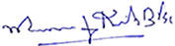
MAURICE JOHN KIRK
Claimant in Person
7th December 2021
,,

